

Department of Computer Science and Engineering

Course Code: CSE302

Course Title: Database Systems

Section: 01

Semester: Fall 23

**LAB 01**

**Submitted to:**

**Dr. Mohammad Rezwanul Huq**

Associate Professor

Department of Computer Science and Engineering

East West University

**Submitted by:**

**Name:** B M Shahria Alam

**ID:** 2021-3-60-016

**Date of submission:** 14th October, 2023.

**Lab Task # 01 (Creating a table):**

**(A)**

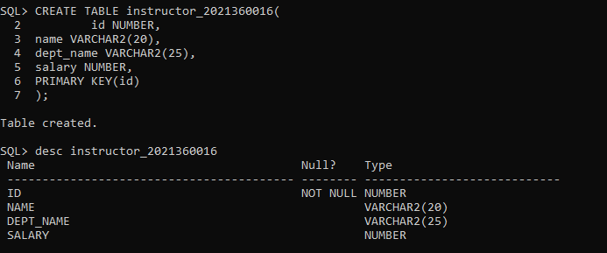

**(B)**

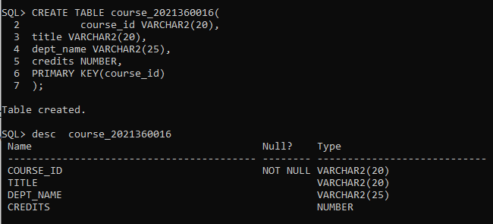

**Lab Task # 02 (Inserting data into a table):**

**(A)**

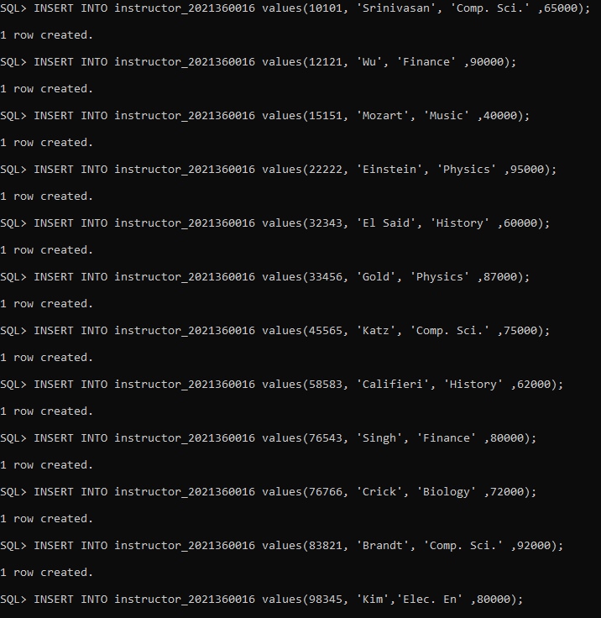

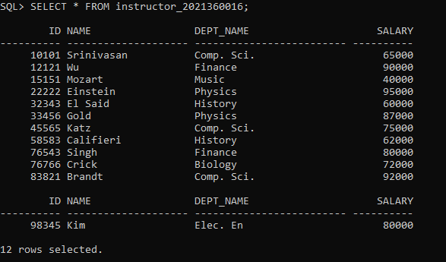

**(B)**

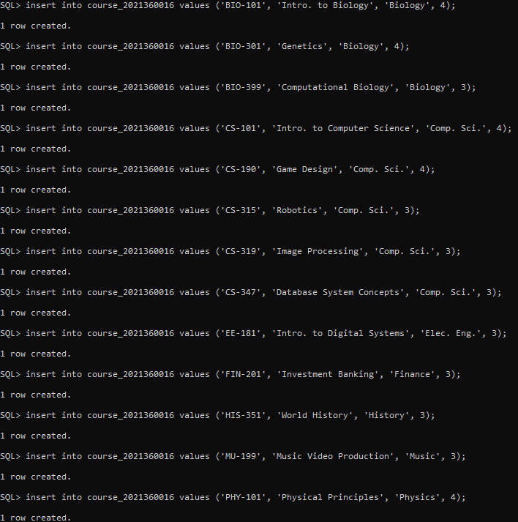

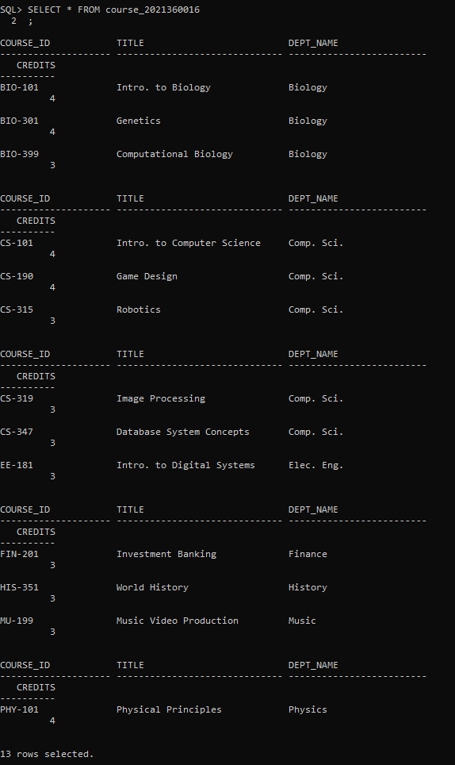

**Lab Task # 03 (Writing Queries):**

**i)**

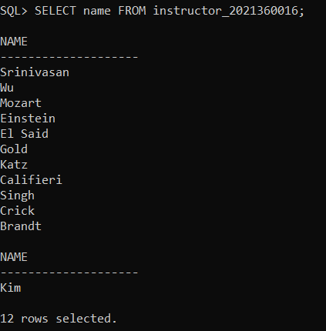

**ii)**

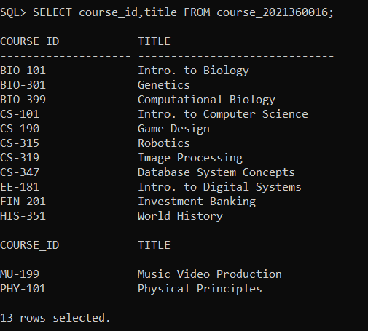

**iii)**

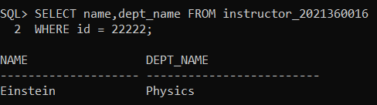

**iv)**

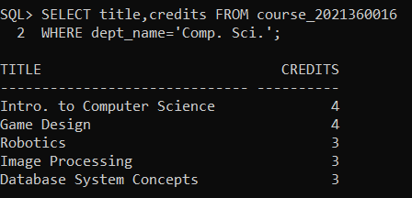

**v)**

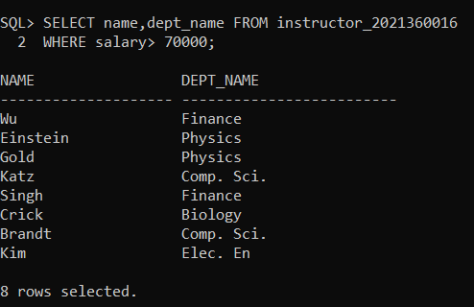

**vi)**

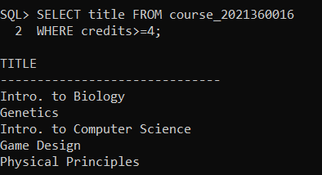

**vii)**

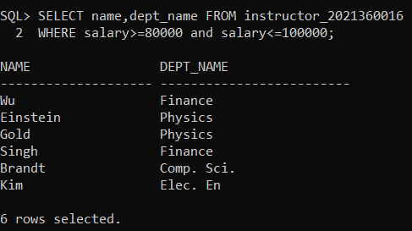

**viii)**

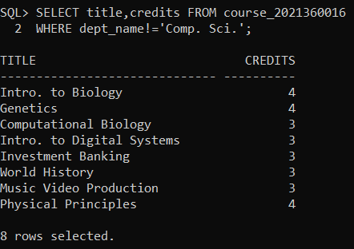

**ix)**

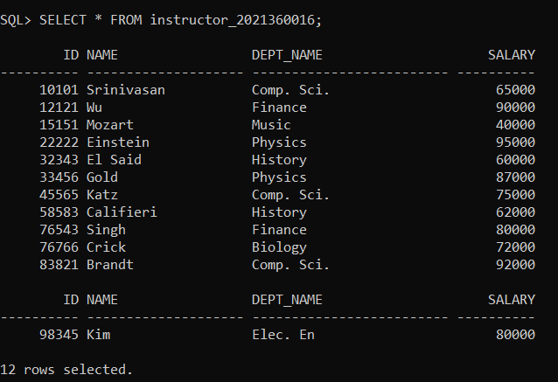

**x)**

